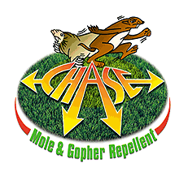
Chase Liquid Mole
and Gopher Repellent
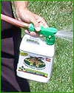
- New, higher 80% active content formula
- Higher margins and lower retail price than others
- Features a faster “wetter” for quick soil penetration
- Attractive, eye catching package that moves!
- Supported by high end consumer website
- Available in 32 oz RTU, gallons and drums too
- Features new absolute locking neck to end leaks

PPI 8459 U S Highway 42, Florence, KY 41042 (859) 525-7353 www.chase-mole.com

