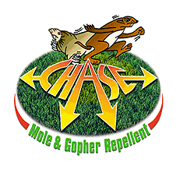
Chase Granular Mole
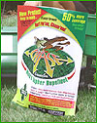and Gopher Repellent
- Uses same effective ingredients as Chase liquid
- Delivers higher margins and lower selling price
- Covers up to 50% more area per pound than others
- Granule size allows drop or broadcast spreader use
- Can be applied by hand as well as all spreaders
- Attractive six color plastic bag really promotes sales
- Use instructions printed on bag are clear and concise
- Available in 32 # bulk carton for commercial users
- Uses non EPA restricted ingredients

PPI 8459 U S Highway 42, Florence, KY 41042 (859) 525-7353 www.chase-mole.com

