

CHASE GREEN GLOVE
GARDENING HAND CREME

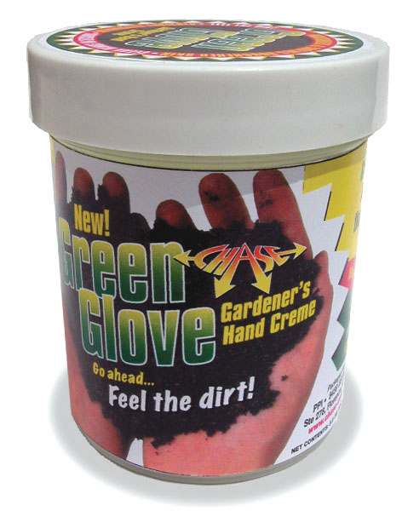

- Greaseless, botanically enriched hand creme for gardeners.
- Soothes and moisturizes rough skin - it's manicure safe!
- Makes after gardening cleanup better and faster.
- Easy to apply, greaseless, dries in seconds.
- Comes in easy to assess 3.5 ounce jars.
- Fresh smelling spearmint scent.
- Packed twelve jars in a point of purchase display.
- Great profit building impulse seller!

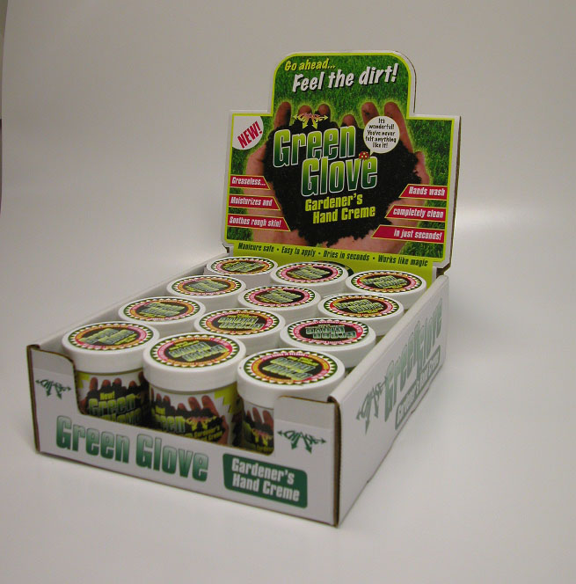

PPI 8459 U S Highway 42, Florence, KY 41042 (859) 525-7353 www.chase-mole.com

