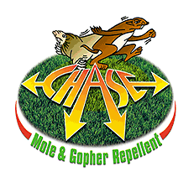
Chase Plant and Bulb
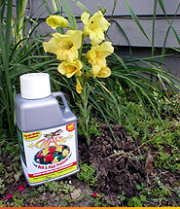
Protector

- Unique – the first of its kind for great margins
- A great add-on item to all plant and bulb sales
- Prevents future pests & controls present ones
- Effective against all types of burrowing pests
- Can be hand broadcast or used in any spreader
- Uses non EPA restricted ingredients

PPI. 8459 U S Highway 42, Florence, KY 41091 (859) 525-7353 www.chase-mole.com

