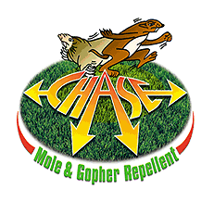

CHASE DEER REPELLENT
& PLANT PROTECTOR

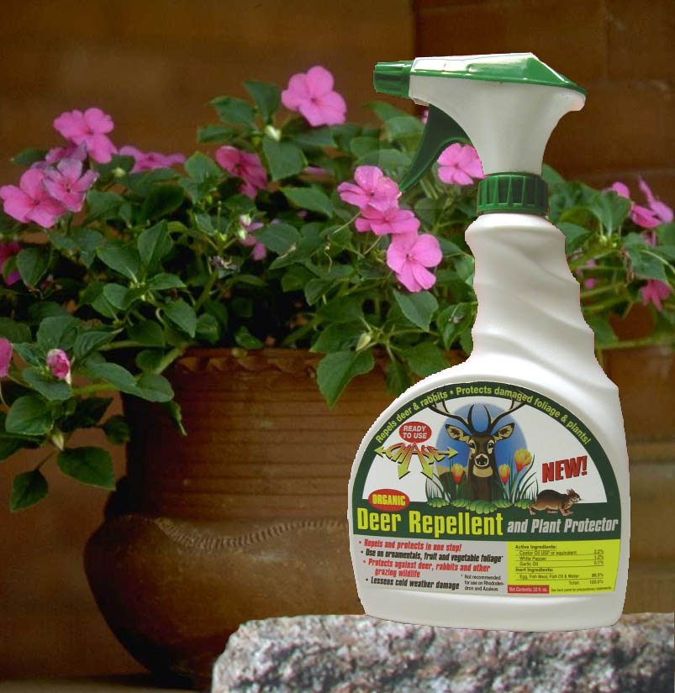

- Repels Deer, Rabbits and other plant damaging pests!
- Allows damaged plants to regain vigorous growth naturally.
- Dual action formula causes deer to reject immediately and not return
- Lessens cold weather wilting and freeze damage.
- Unique clinging film formula resists wash off - lasts 60-90 days!
- Safe on most ornamentals, fruits and vegetable plants
- Delivers high margins and satisfied customers.

PPI 8459 U S Highway 42, Florence, KY 41042 (859) 525-7353 www.chase-mole.com

